To setup paypal payment system in R12, log into either Funds Capture Setup Admin or Payment Setup Admin responsibility. Follow the directions outlined in the screen shots below to perform the required setup:

- Create Paypal payment system by clicking onn Go To Task next to Payment Systems link and then clicking on Create button.

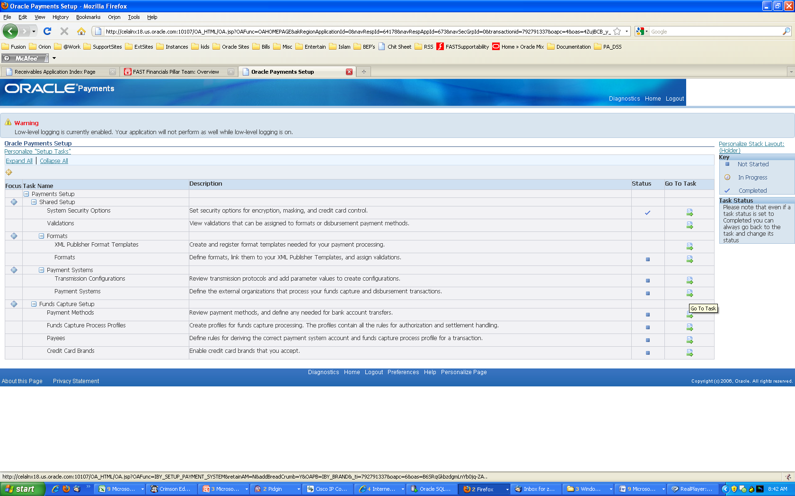

2. In create payment system page, enter following details
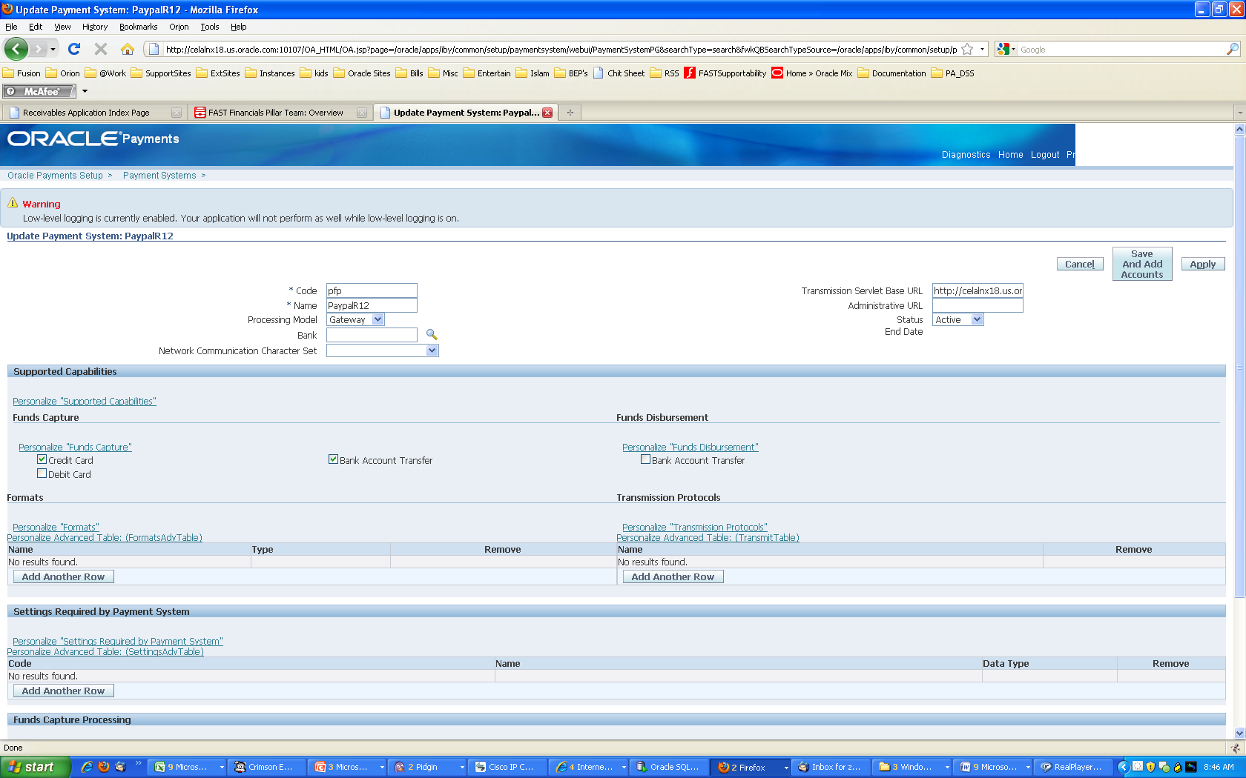

3. Click on Save and Add Accounts button
4. In Payment System Accounts page, click on Add Another Row button and create an account by entering paypal credentials in the following format:

<User>:<Password>:<Vendor>:<Partner>
For example, tjohnson:mypassword:tjohnson:PayPal

Save Payment System

Next step is to assign the payment system account to a payee. You can either create a new payee or assign the paypal account to existing payee. For this example, lets create a new payee

- Click on Go To Task icon next to payee link and then click on Create to create new payee
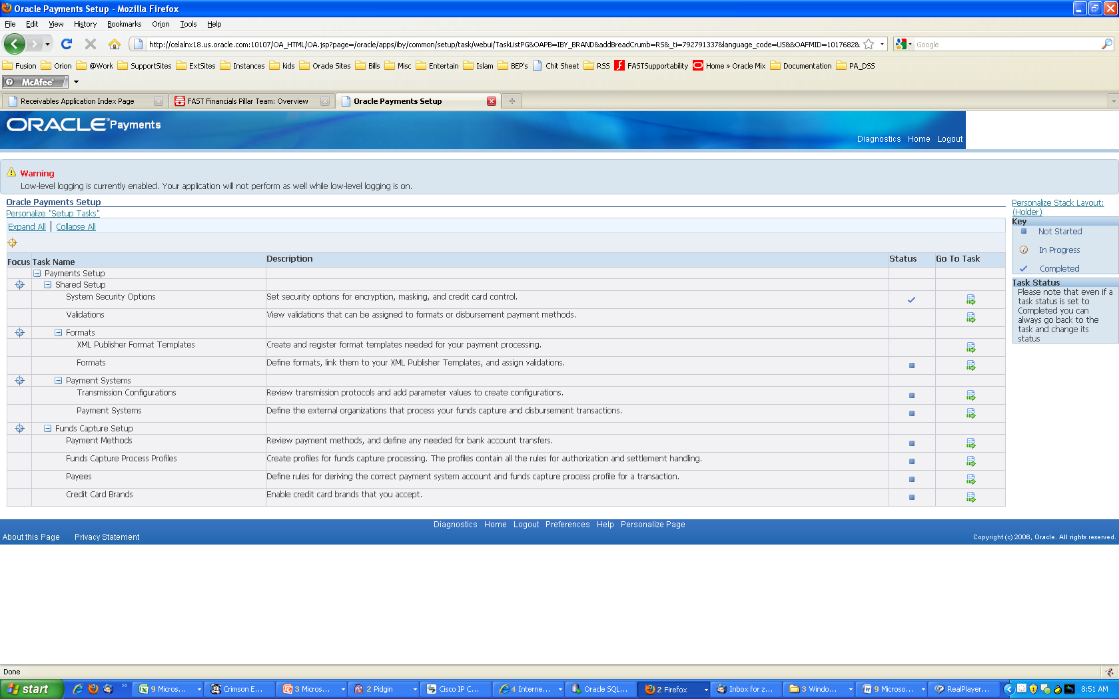

- Enter the following details on Create payee page

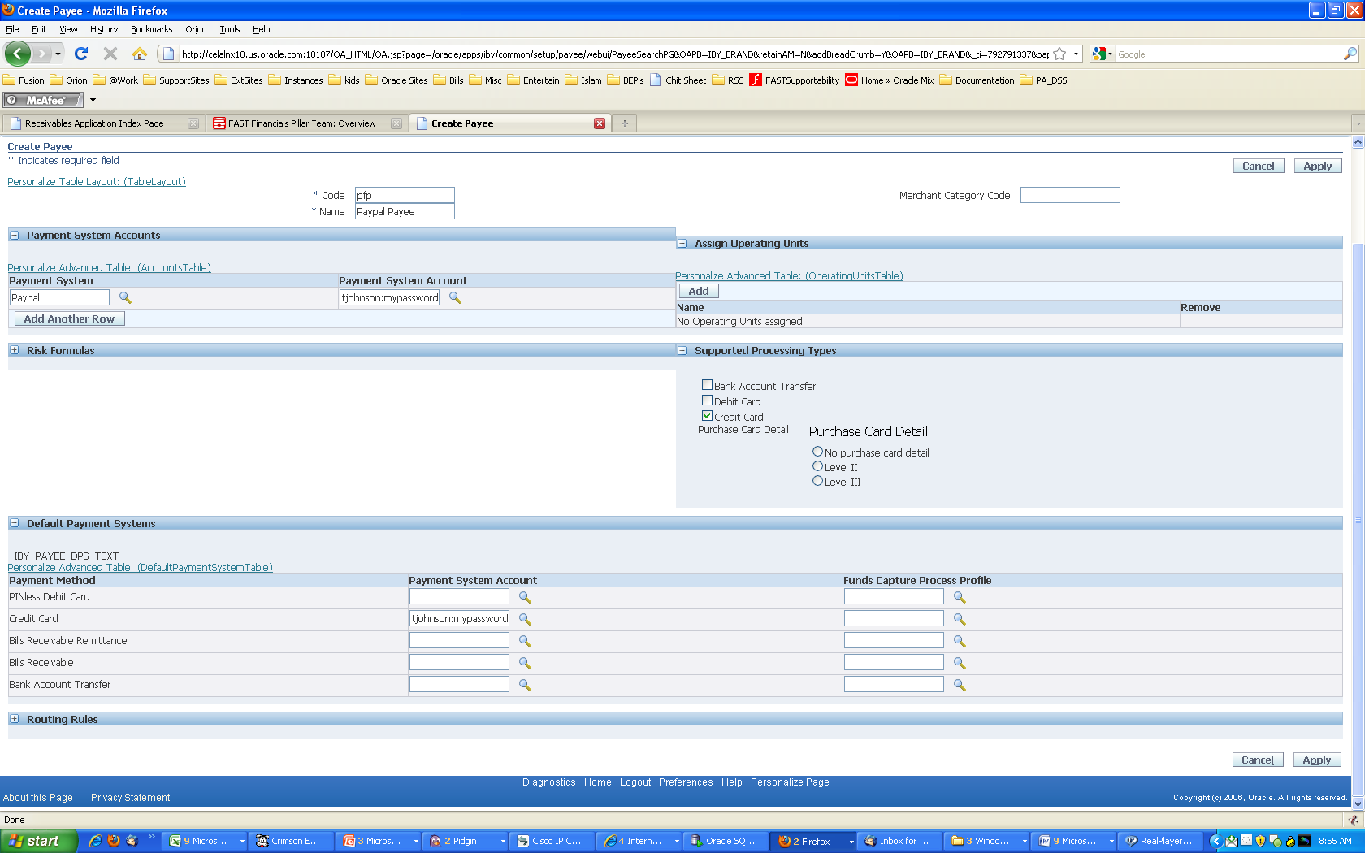

Note:
- Setup of default payment system account is required
- Use payee routing rules only if you have multiple payment systems or payment system accounts
- Do not forget to associate your operating unit with the payee.

